# CS 255 System Design Document Template

## UML Diagrams

### UML Use Case Diagram

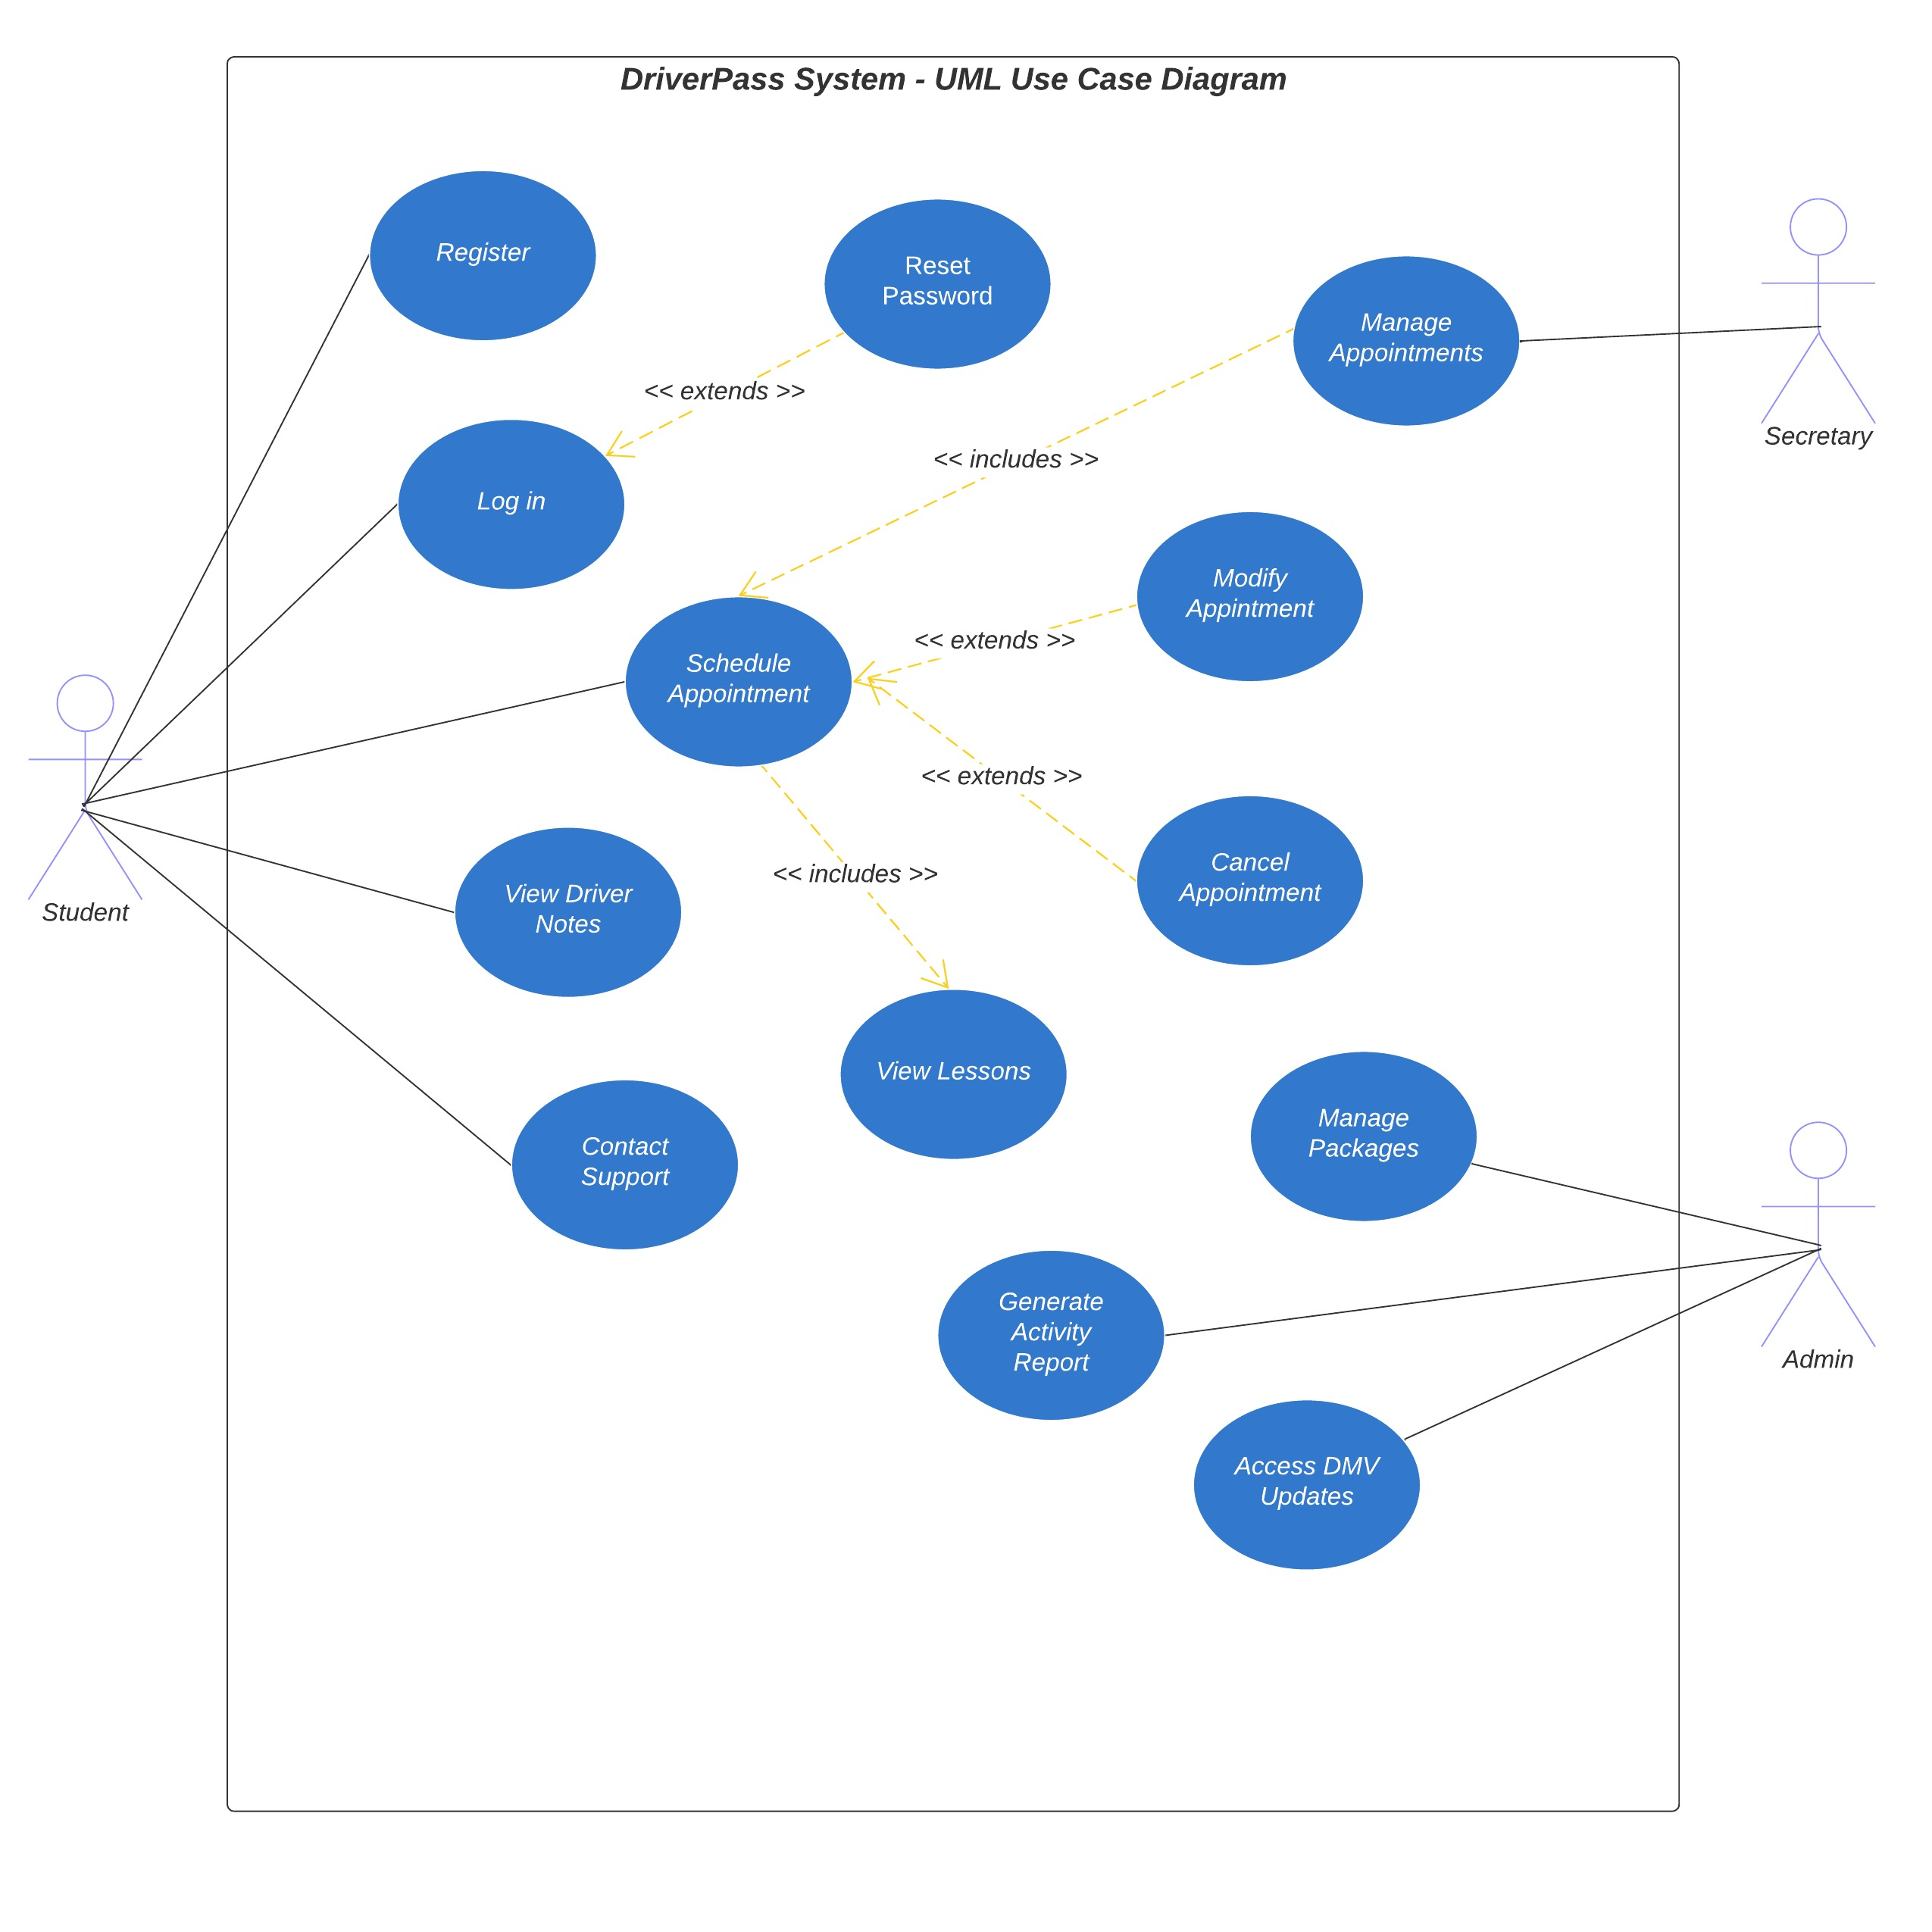

### UML Activity Diagrams

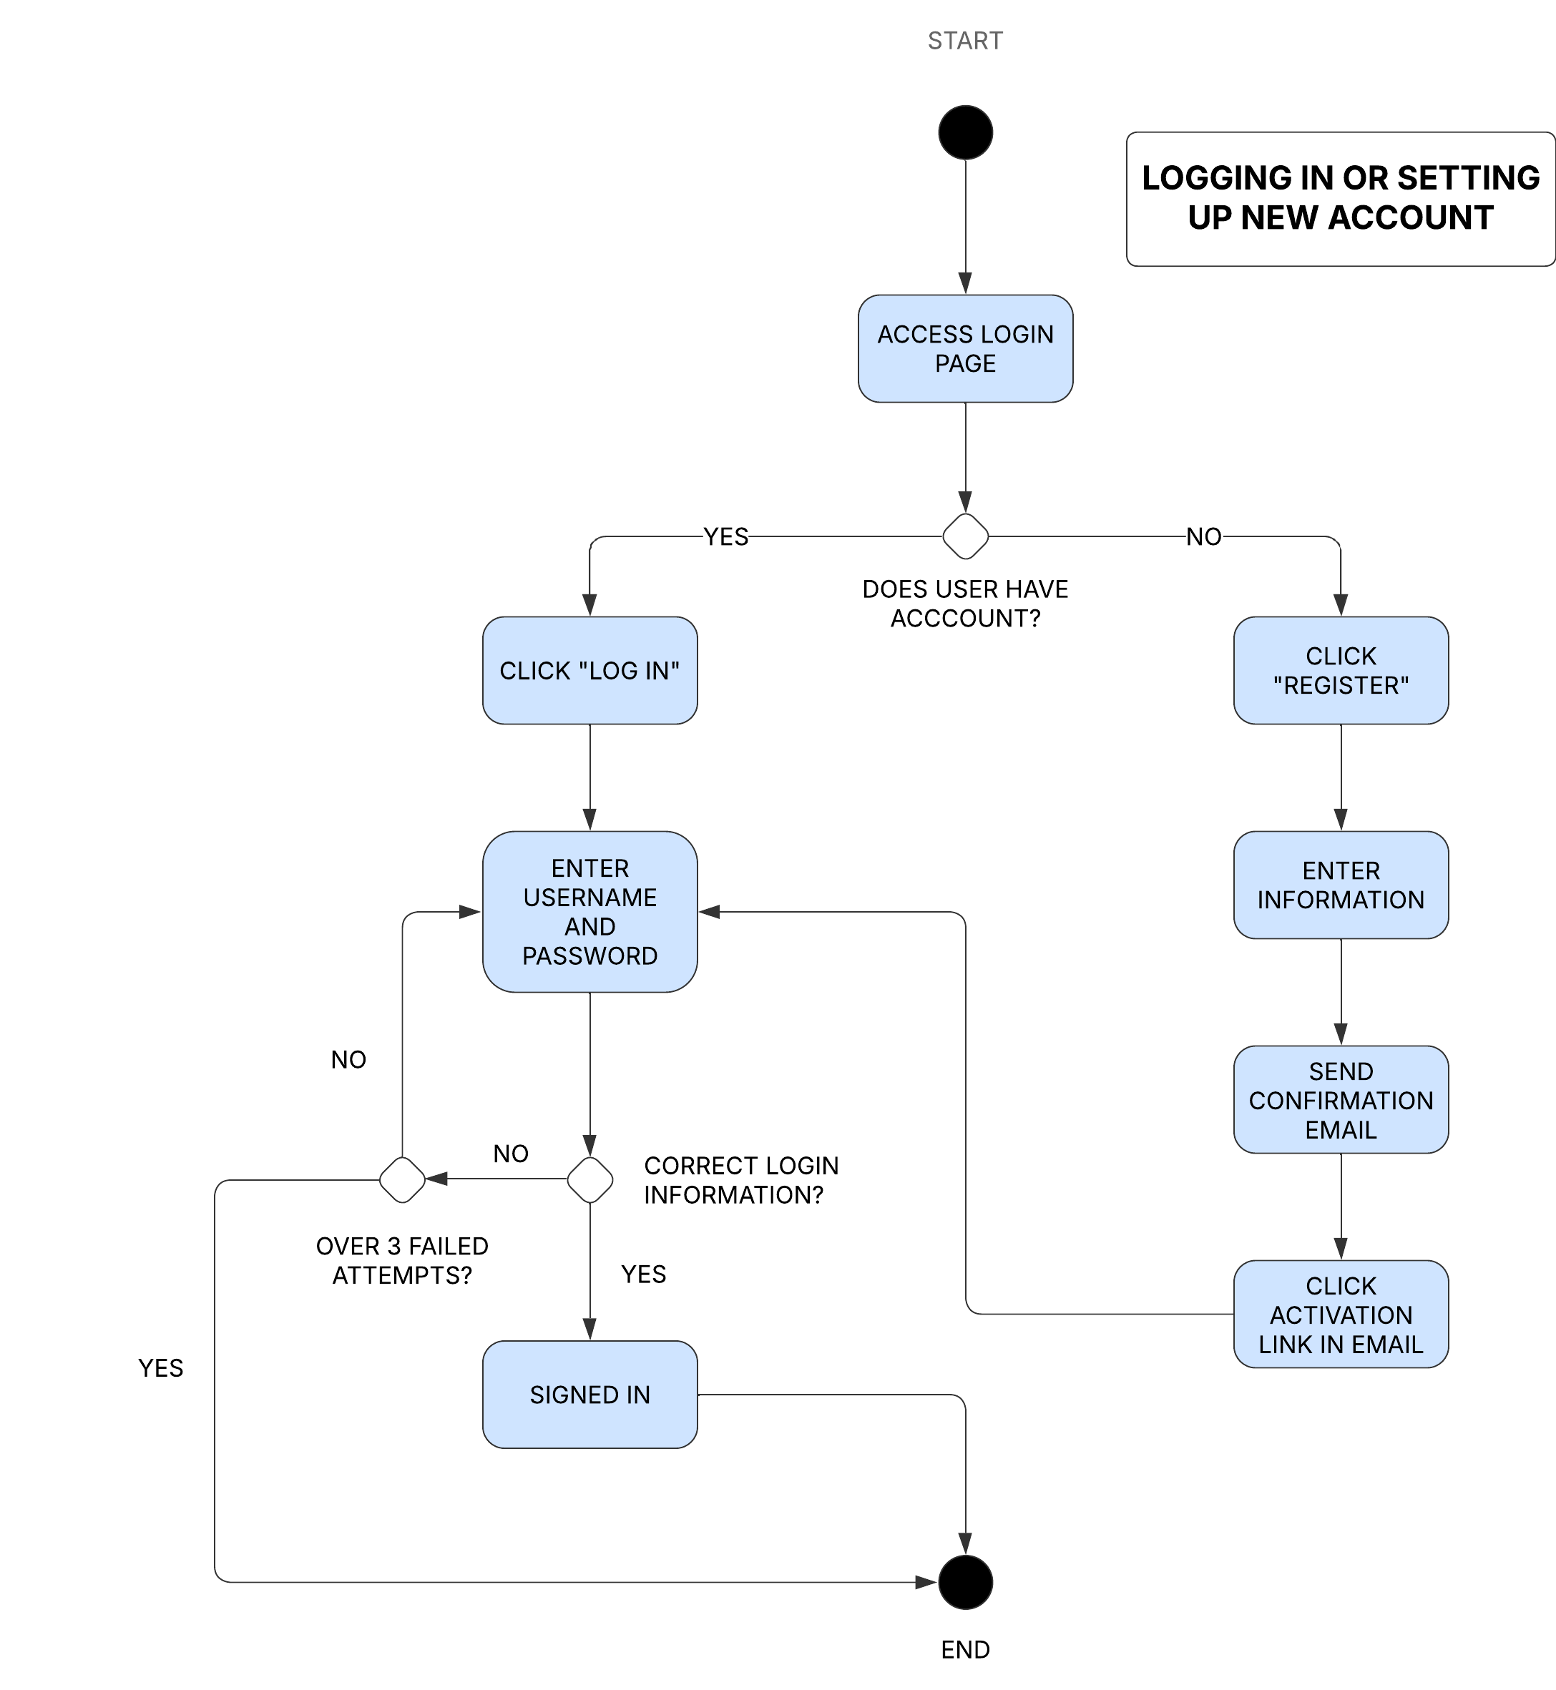 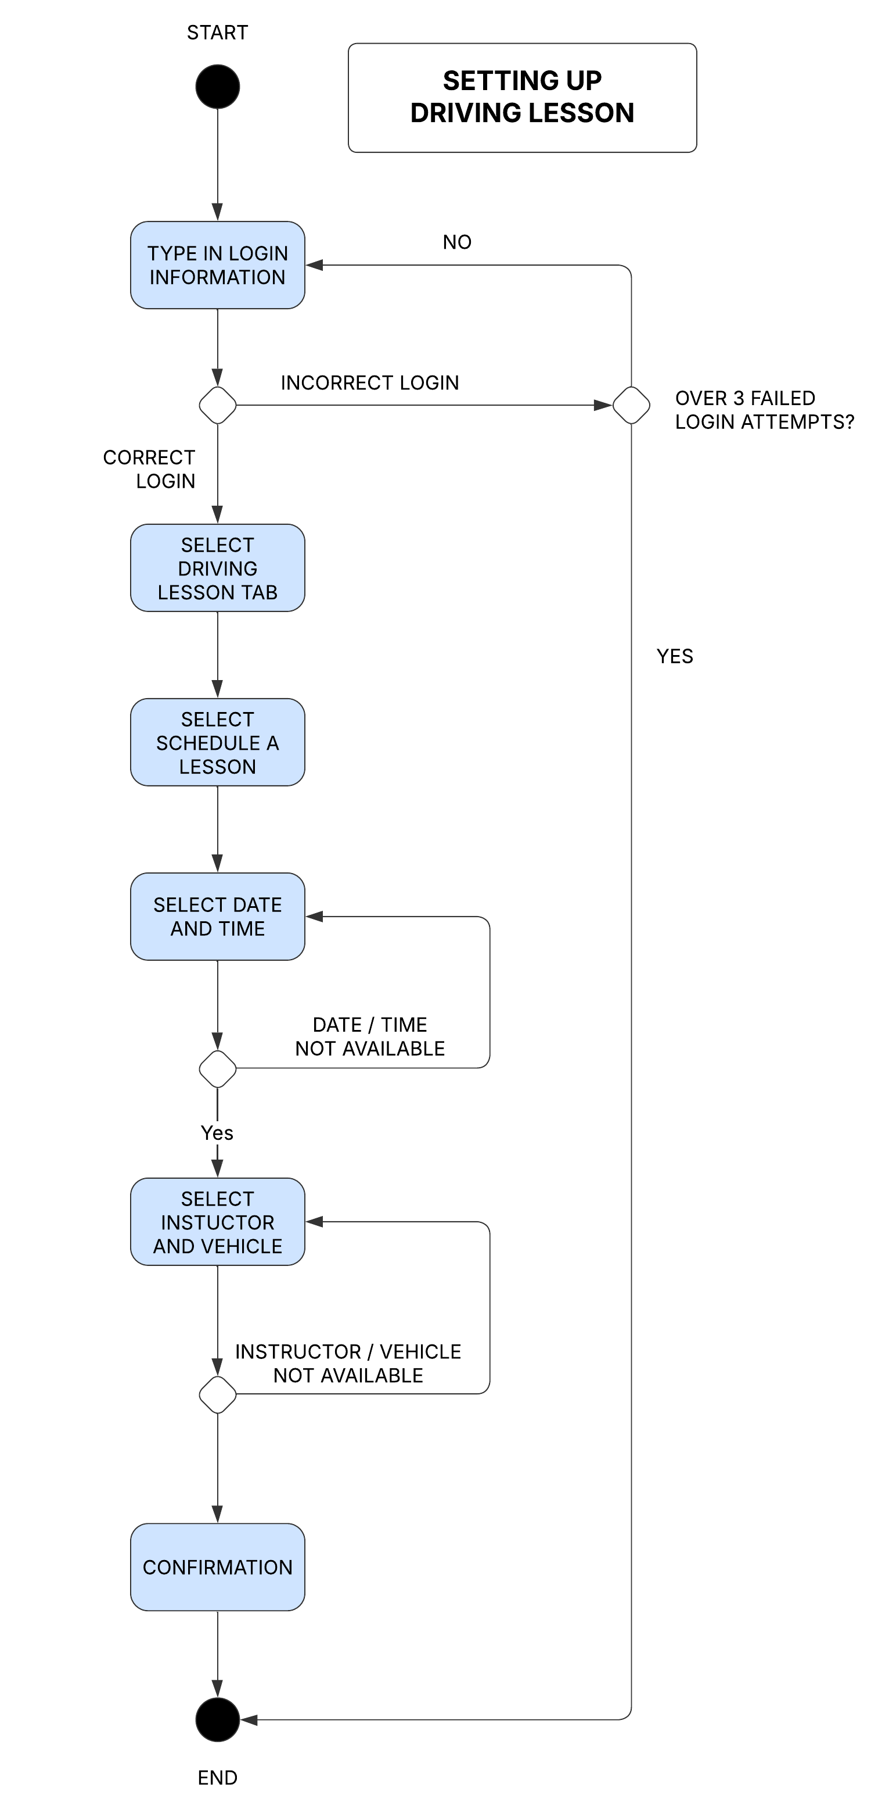

### UML Sequence Diagram

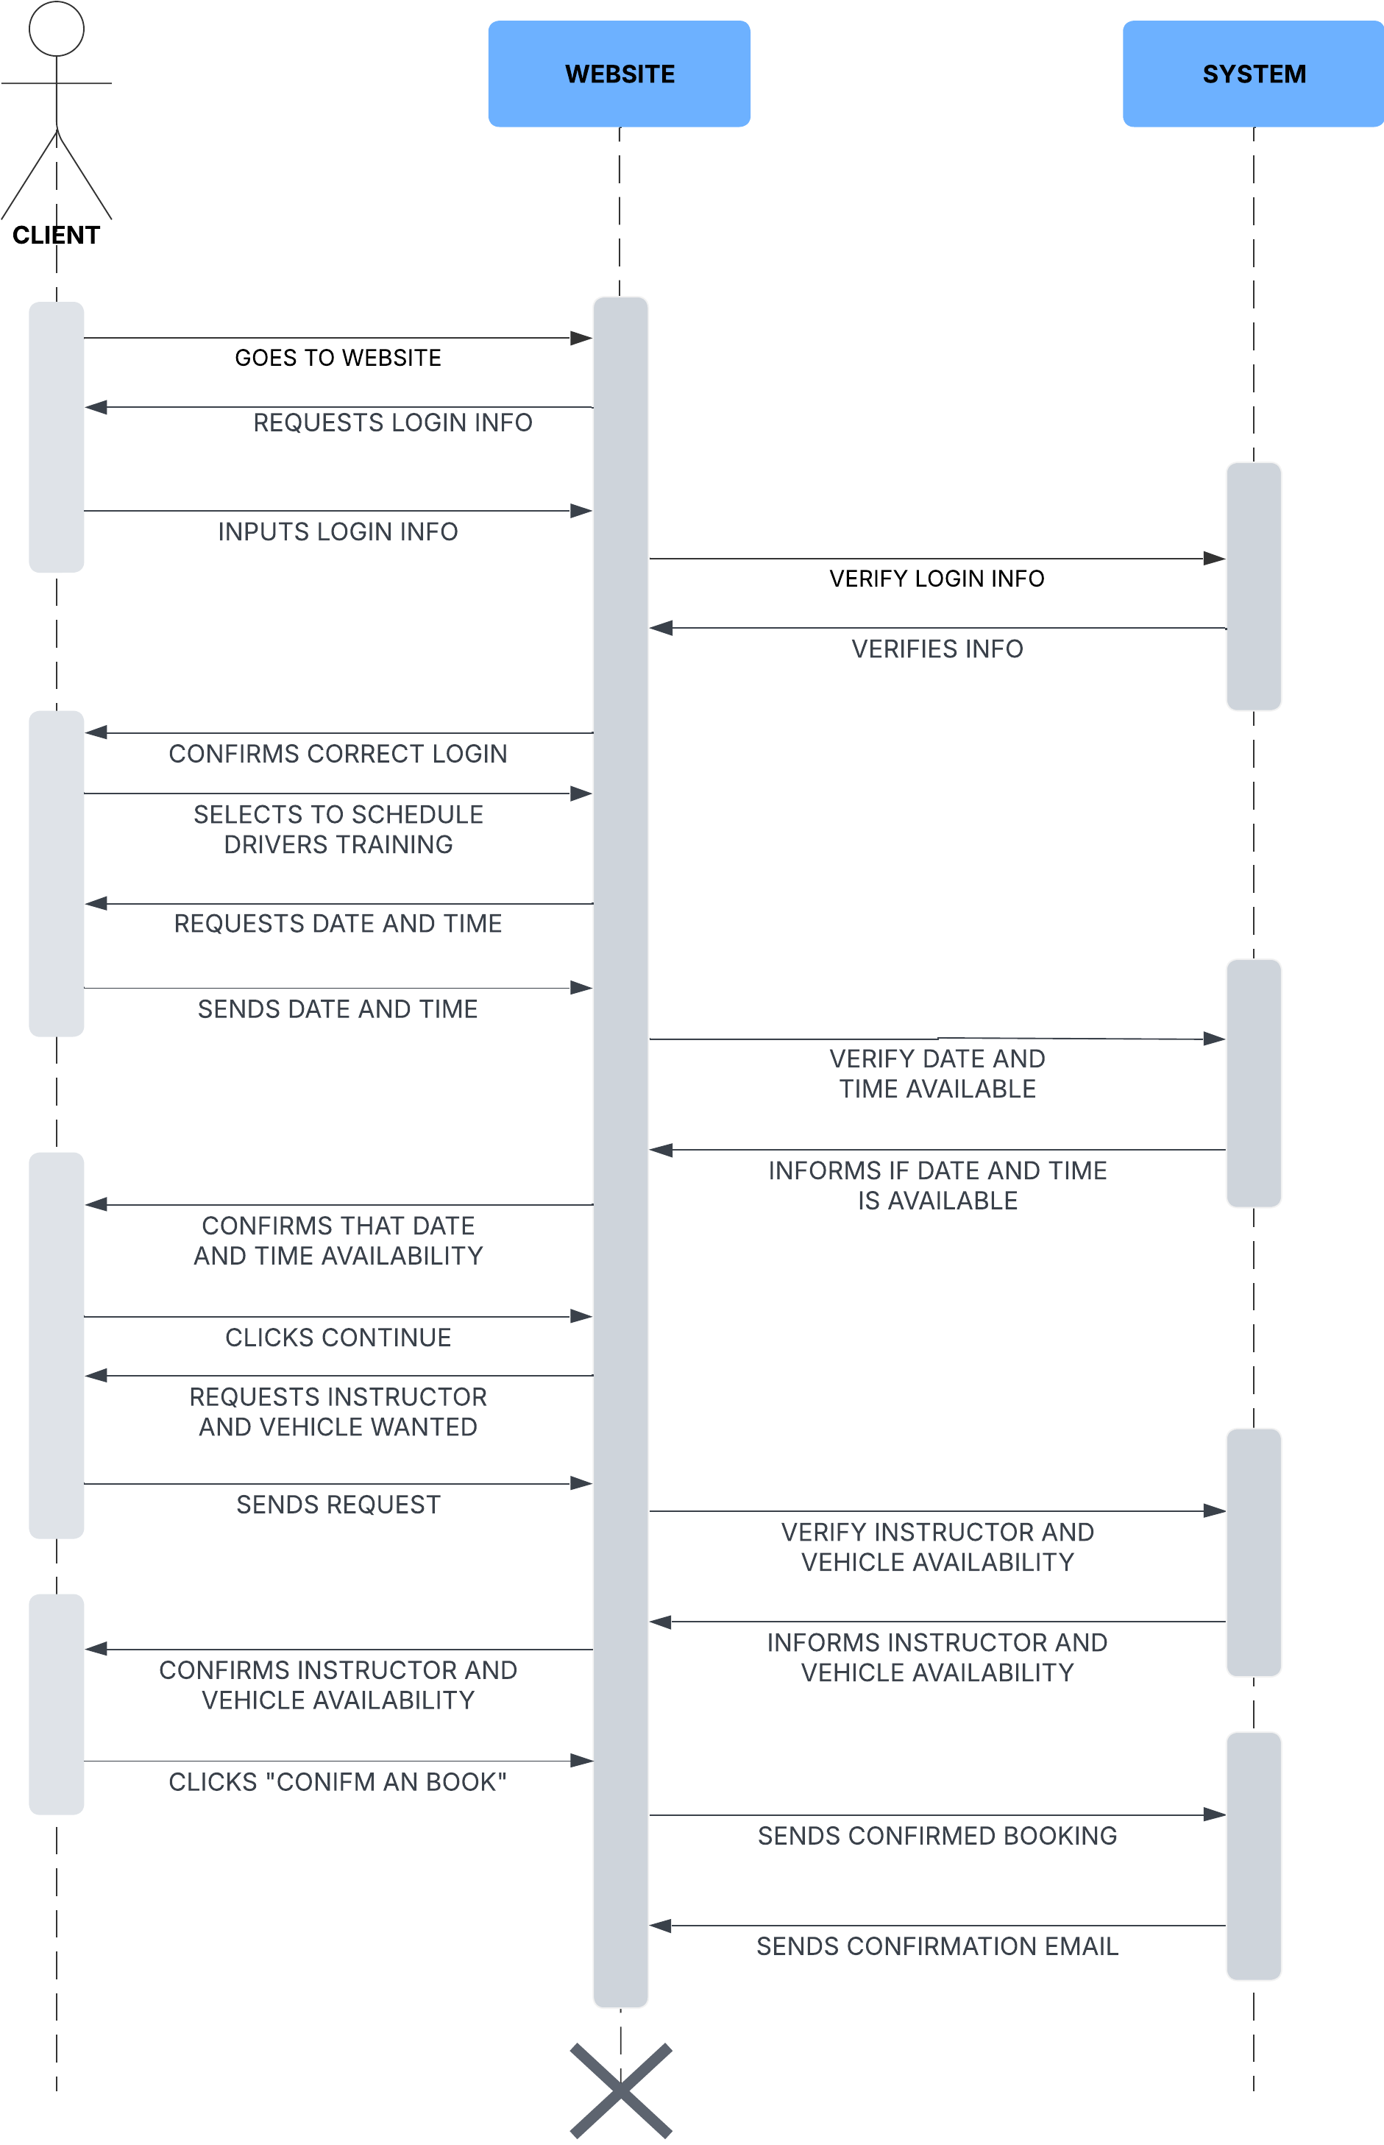

### UML Class Diagram

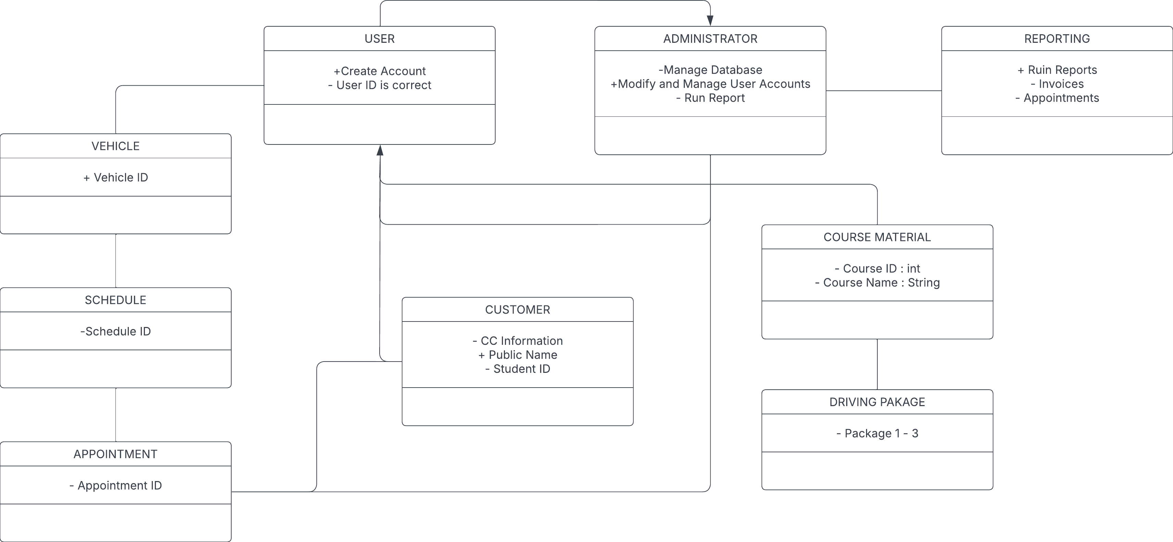

## Technical Requirements

*There should be a server dedicated to this program as well as an ample amount of storage. The company needs to have a strong and reliable internet connection. The program needs to be able to run on all operating systems and web browsers. Make sure security software is up to date to prevent trojens, hacking and malware. It would be best to update systems and security software at least once a month if not more. The system should let students create unique username and password (passwords should have a standard minimum of lowercase, uppercase and special character). The system should be easy to use for the client and admins. Admins should be able to see and change user information and appointments if needed. The company’s IT department should be trained in how to use and update the software if needed.*